[CSE102 Lecture on 2021-03-01 Part 1 of 2](https://youtu.be/wVD9H6GaYM8)

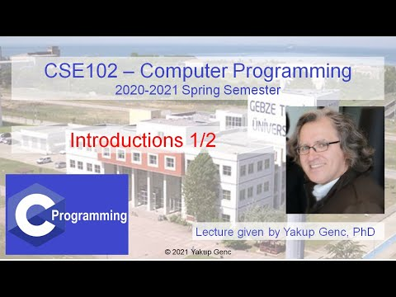

[CSE102 Lecture on 2021-03-01 Part 2 of 2](https://youtu.be/qdaze8ivoNU)

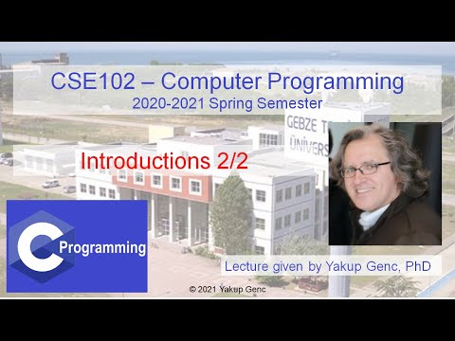

[CSE102 Lecture on 2021-03-02 Part 1 of 2](https://youtu.be/rW5VJlNFOXo)

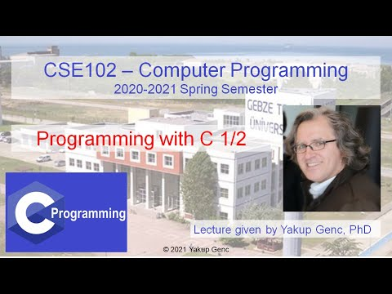

[CSE102 Lecture on 2021-03-02 Part 2 of 2](https://youtu.be/XlTdg0q6NqE)

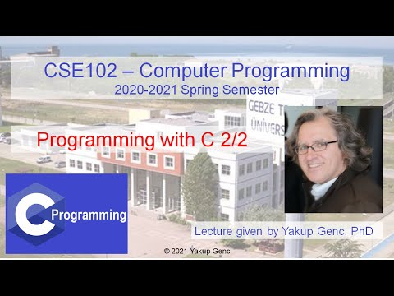

[CSE102 Lecture on 2021-03-03 Part 1 of 2](https://youtu.be/wEWWR14lgok)

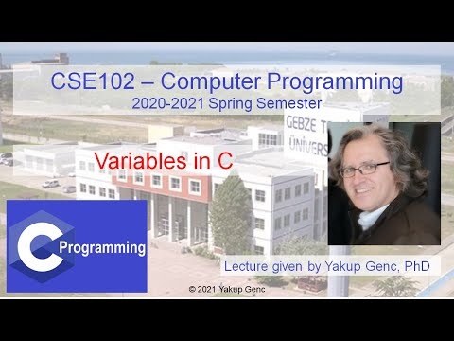

[CSE102 Lecture on 2021-03-03 Part 2 of 2](https://youtu.be/uREQmoT-cug)

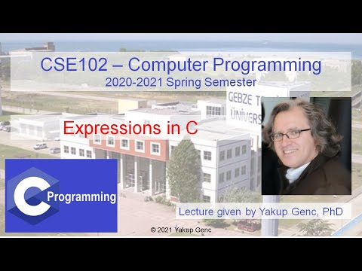

[CSE102 Lecture on 2021-03-08 Part 1 of 2](https://youtu.be/16eqk6SzOHM)

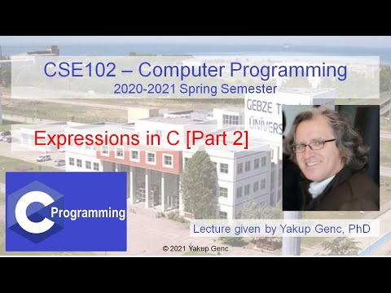

[CSE102 Lecture on 2021-03-08 Part 2 of 2](https://youtu.be/gxvgUmfv1tk)

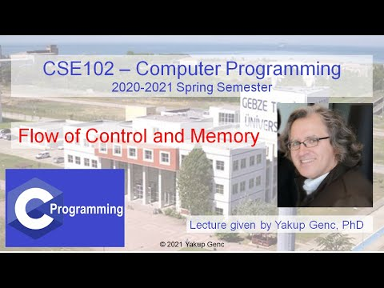

[CSE102 Lecture on 2021-03-09 Part 1 of 2](https://youtu.be/7_DS63unWDk)

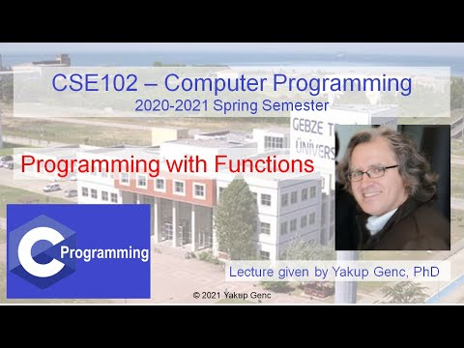

[CSE102 Lecture on 2021-03-09 Part 2 of 2](https://youtu.be/5irIaNbGYpQ)



[CSE102 Lecture on 2021-03-10 Part 1 of 2](https://youtu.be/dbFHWHg145M)

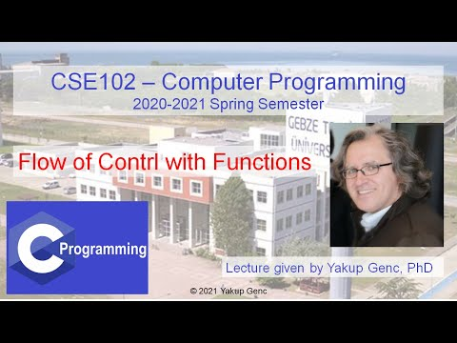

[CSE102 Lecture on 2021-03-10 Part 2 of 2](https://youtu.be/i5sbSL9ilKs)



[CSE102 Lecture on 2021-03-15 Part 1 of 2](https://youtu.be/Wfma4LJMAu0)

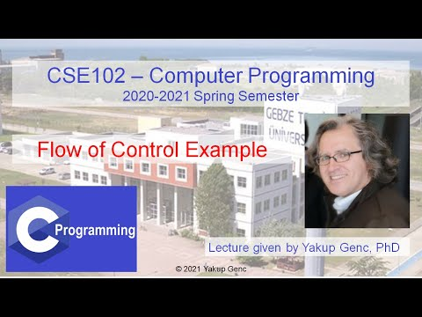

[CSE102 Lecture on 2021-03-15 Part 2 of 2](https://youtu.be/7fihUN-lDtk)

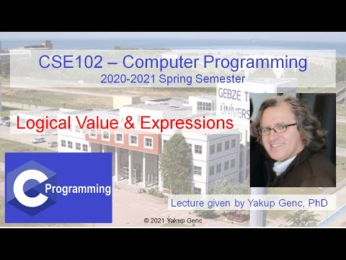

[CSE102 Lecture on 2021-03-16 Part 1 of 2](https://youtu.be/F387ZtWDceg)

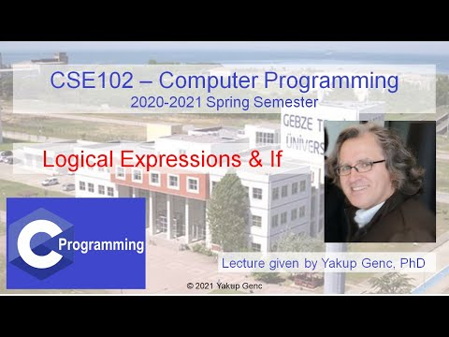

[CSE102 Lecture on 2021-03-16 Part 2 of 2](https://youtu.be/4tvbsli6Ce4)

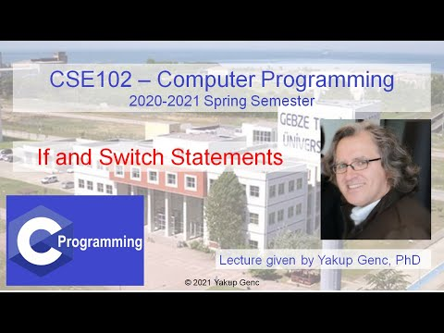

[CSE102 Lecture on 2021-03-17](https://youtu.be/66TdNKAhNYU)

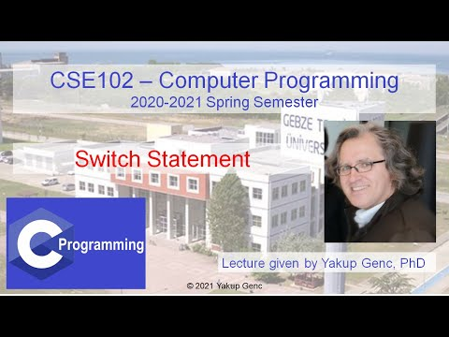

[CSE102 Lecture on 2021-03-22 Part 1 of 2](https://youtu.be/jMBgsYTJprM)

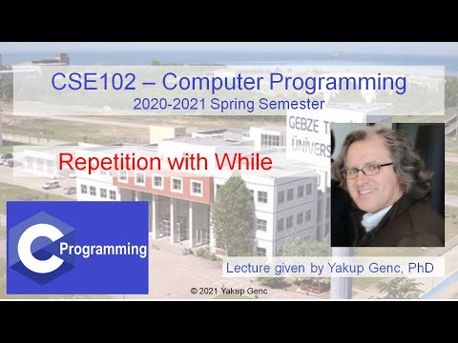

[CSE102 Lecture on 2021-03-22 Part 2 of 2](https://youtu.be/Nl2HmtCqqjQ)

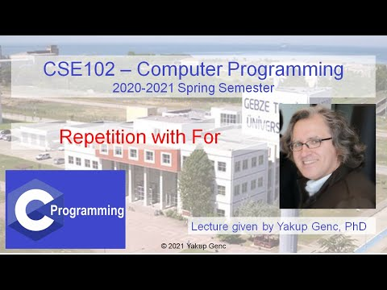

[CSE102 Lecture on 2021-03-23 Part 1 of 2](https://youtu.be/QlCT716JIZM)

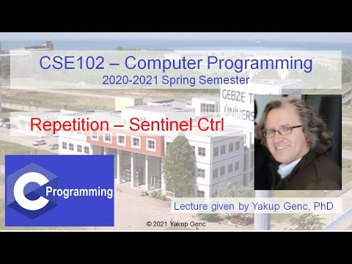

[CSE102 Lecture on 2021-03-23 Part 2 of 2](https://youtu.be/H4JK7XlH_eo)

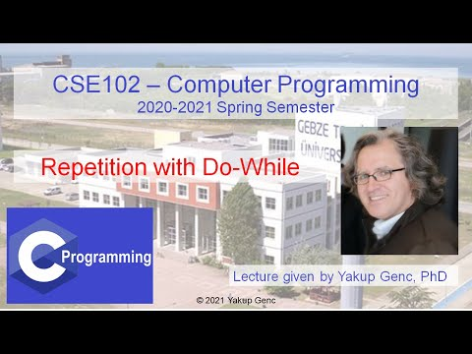

[CSE102 Lecture on 2021-03-29 Part 1 of 2](https://youtu.be/TYKazr30aOA)

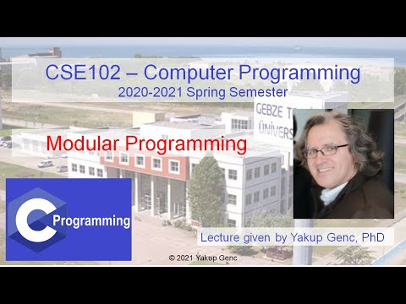

[CSE102 Lecture on 2021-03-29 Part 2 of 2](https://youtu.be/vY1nKvMr0JY)

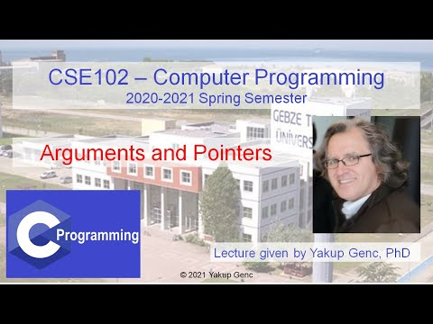

[CSE102 Lecture on 2021-03-30 Part 1 of 2](https://youtu.be/vSbBg3RyWhg)



[CSE102 Lecture on 2021-03-30 Part 1 of 2](https://youtu.be/hACNOshUTA8)

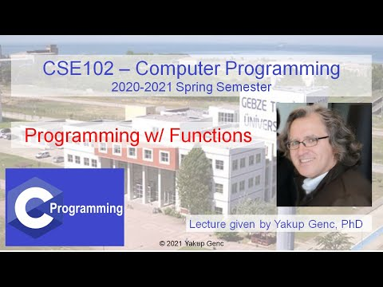

[CSE102 Lecture on 2021-03-31 Part 1 of 2](https://youtu.be/LIdUPrxVg_M)

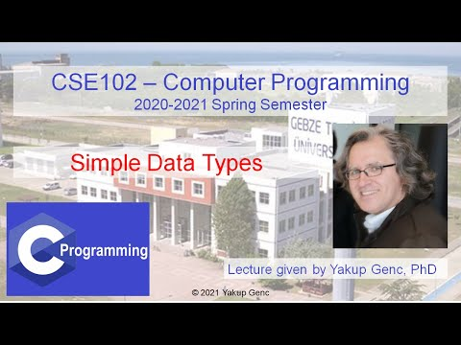

[CSE102 Lecture on 2021-03-31 Part 2 of 2](https://youtu.be/zGUKtyhNgtU)

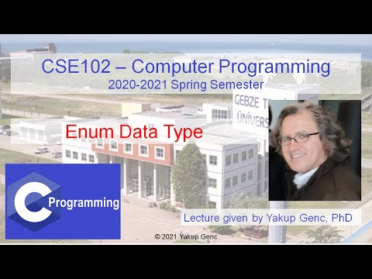

[CSE102 Lecture on 2021-04-05 Part 1 of 2](https://youtu.be/jiH-lvznCMI)

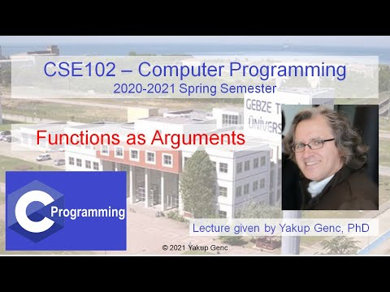

[CSE102 Lecture on 2021-04-05 Part 2 of 2](https://youtu.be/_0Z0dZwsVFc)

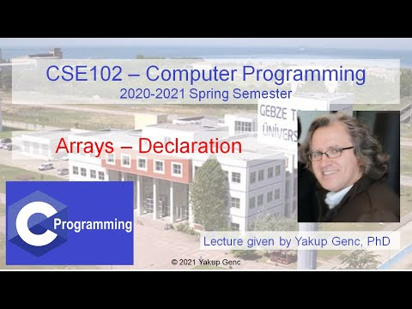

[CSE102 Lecture on 2021-04-06 Part 1 of 2](https://youtu.be/LVwMqvDC83A)

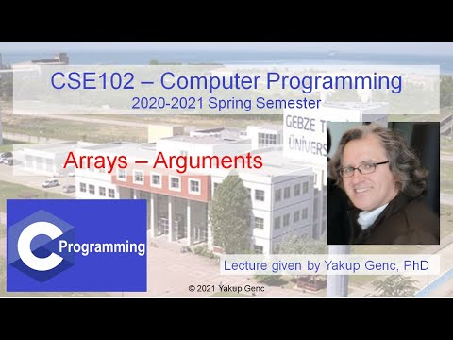

[CSE102 Lecture on 2021-04-06 Part 2 of 2](https://youtu.be/8Q9GKFTZ7iw)

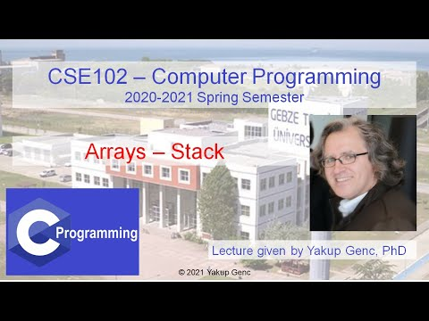

[CSE102 Lecture on 2021-04-07 Part 1 of 2](https://youtu.be/p5NaDx6jAxY)

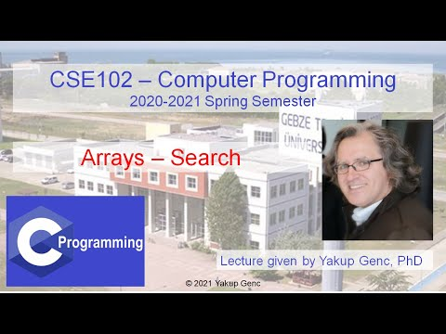

[CSE102 Lecture on 2021-04-07 Part 2 of 2](https://youtu.be/mi4I6_YvV_A)

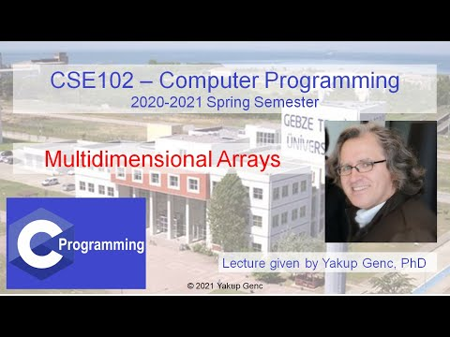

[CSE102 Lecture on 2021-04-12 Part 1 of 2](https://youtu.be/ZR1GVAcH-20)

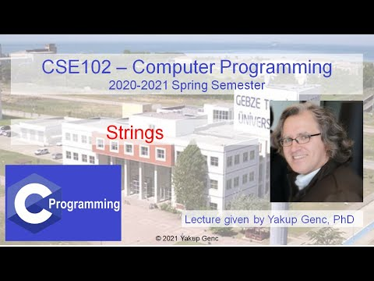

[CSE102 Lecture on 2021-04-12 Part 2 of 2](https://youtu.be/DPbB7GieUqo)

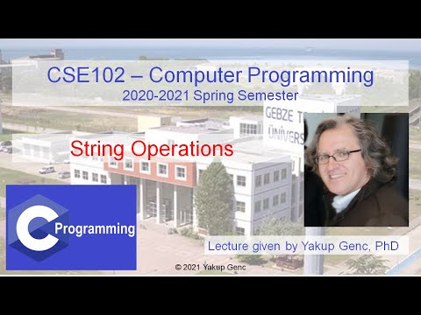

[CSE102 Lecture on 2021-04-13](https://youtu.be/L-PGEDCUCrI)

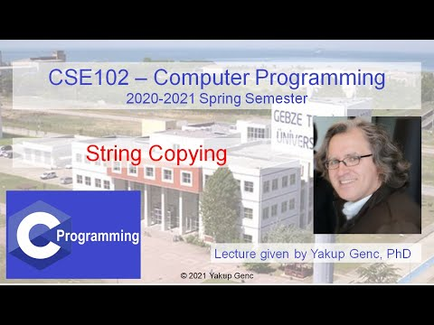

[CSE102 Lecture on 2021-04-14 Part 1 of 2](https://youtu.be/b4lqSsnaa4A)

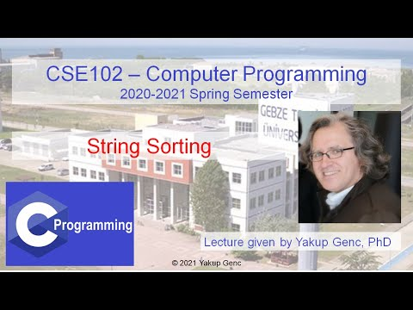

[CSE102 Lecture on 2021-04-14 Part 2 of 2](https://youtu.be/DcM_hXoi30g)

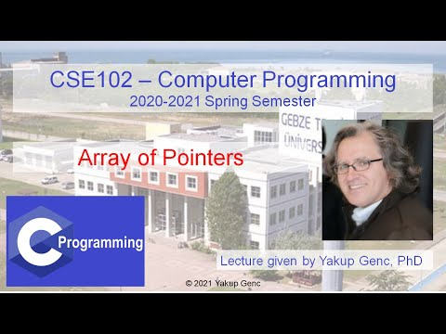

[CSE102 Lecture on 2021-04-19 Part 1 of 2](https://youtu.be/CbH5NDI7p_0)

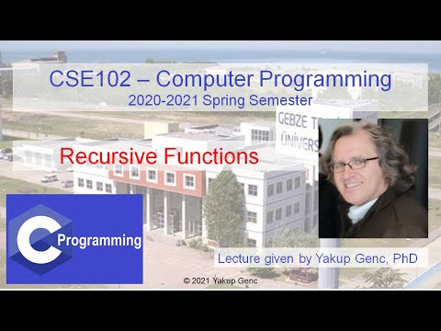

[CSE102 Lecture on 2021-04-19 Part 2 of 2](https://youtu.be/CinLQs8U5VI)

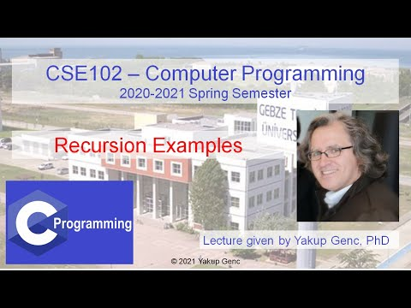

[CSE102 Lecture on 2021-04-20 Part 1 of 2](https://youtu.be/brJ4PO34FJo)

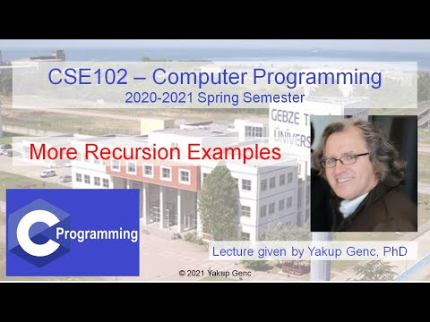

[CSE102 Lecture on 2021-04-20 Part 2 of 2](https://youtu.be/O_mMVa-HkAo)



[CSE102 Lecture on 2021-04-21 Part 1 of 2](https://youtu.be/bp6M68es3wU)

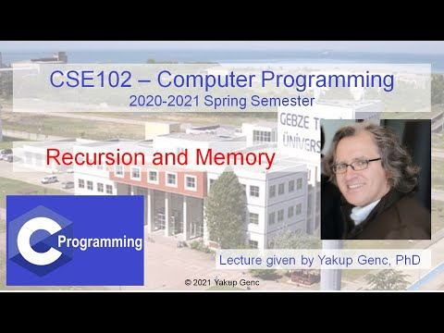

[CSE102 Lecture on 2021-04-21 Part 2 of 2](https://youtu.be/9jW5GEn9Vhw)

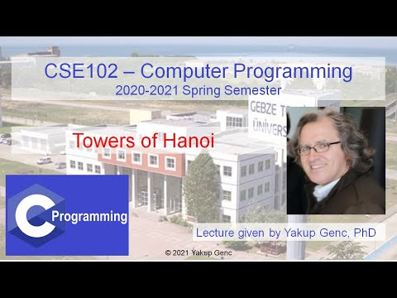

[CSE102 Lecture on 2021-04-26 Part 1 of 2](https://youtu.be/Cw4tKw6ZO10)

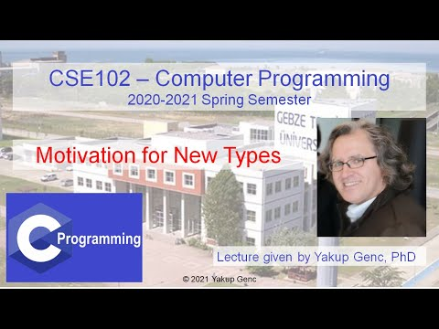

[CSE102 Lecture on 2021-04-26 Part 2 of 2](https://youtu.be/Hp0JXz_CzC8)

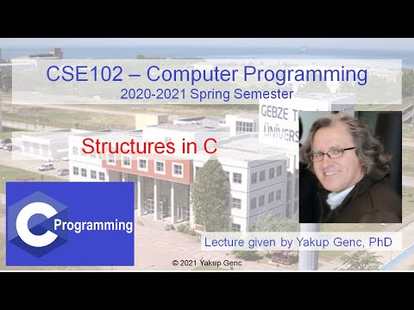

[CSE102 Lecture on 2021-04-27 Part 1 of 2](https://youtu.be/SuZzWoaxkEA)

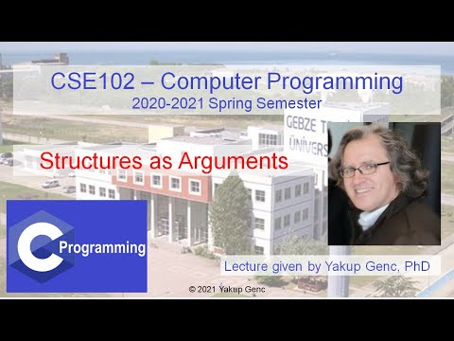

[CSE102 Lecture on 2021-04-27 Part 2 of 2](https://youtu.be/RcM2p3DGypE)



[CSE102 Lecture on 2021-04-28](https://youtu.be/dvI0j2dicrM)

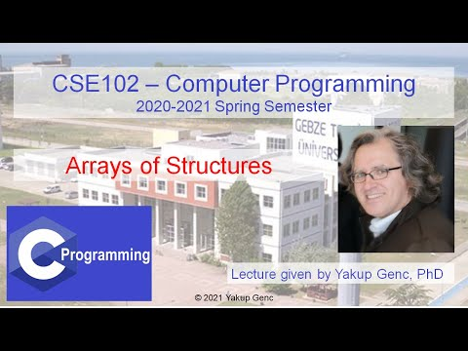

[CSE102 Lecture on 2021-05-04 Part 1 of 2](https://youtu.be/RetGJTIr0CA)

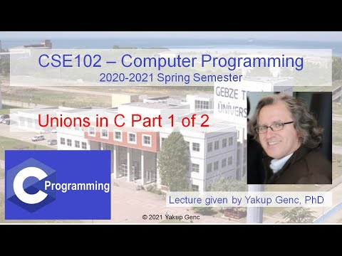

[CSE102 Lecture on 2021-05-04 Part 2 of 2](https://youtu.be/kxWqfzs-xfg)

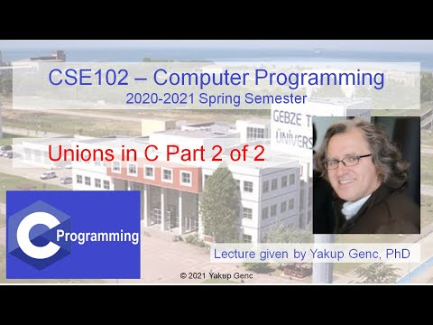

[CSE102 Meeting on 2021-05-10 Part 1 of 2](https://youtu.be/ShDy1e5TkNc)

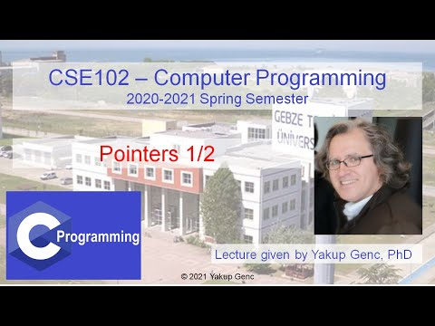

[CSE102 Meeting on 2021-05-10 Part 2 of 2](https://youtu.be/SFXu0DDhdZU)

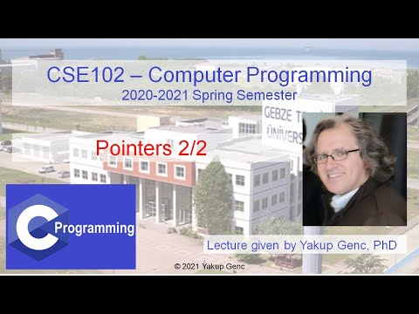

[CSE102 Lecture on 2021-05-11 Part 1 of 2](https://youtu.be/sfadPyIdeA0)

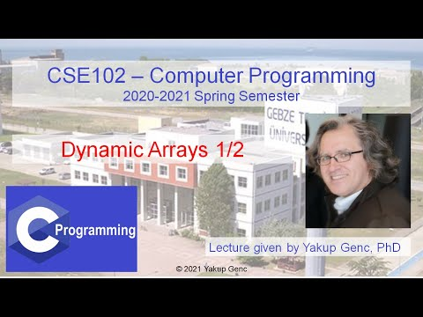

[CSE102 Lecture on 2021-05-11 Part 2 of 2](https://youtu.be/-QyGwziG7pk)

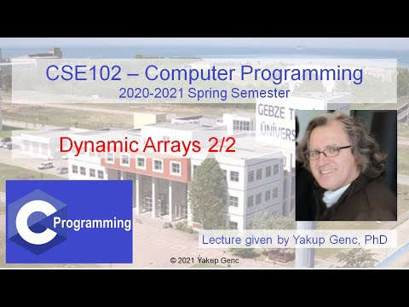

[CSE102 Lecture on 2021-05-17 Part 1 of 2](https://youtu.be/QHTAuykMUK8)

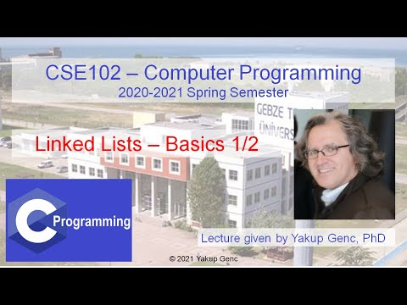

[CSE102 Lecture on 2021-05-17 Part 2 of 2](https://youtu.be/D7vQgVAikb8)

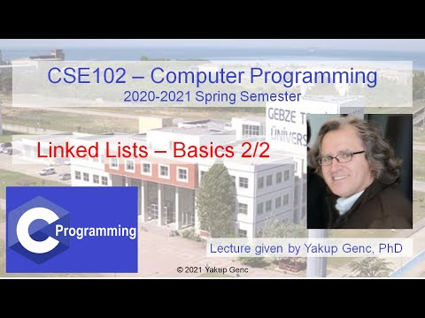

[CSE102 Lecture on 2021-05-18 Part 1 of 2](https://youtu.be/E0NluI_iYdo)

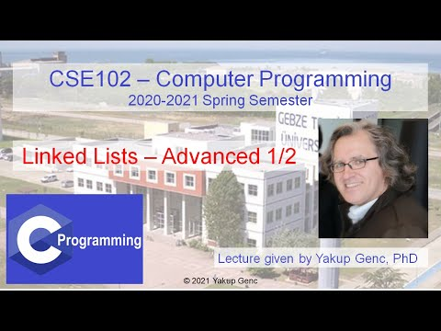

[CSE102 Lecture on 2021-05-18 Part 2 of 2](https://youtu.be/-5KjJu8q3jo)

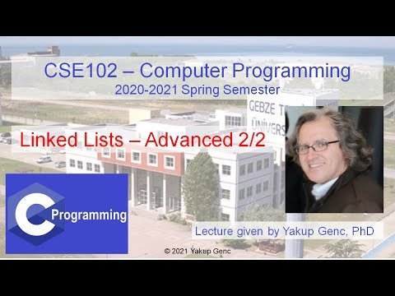

[CSE102 Lecture on 2021-05-24 Part 1 of 2](https://youtu.be/D1tzXPqpHsg)

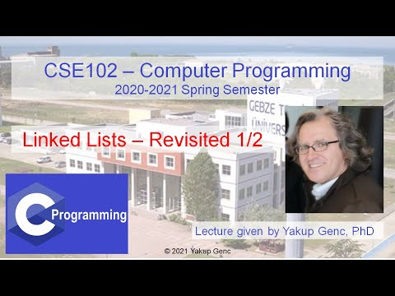

[CSE102 Lecture on 2021-05-24 Part 2 of 2](https://youtu.be/Hl89i3a9DXI)

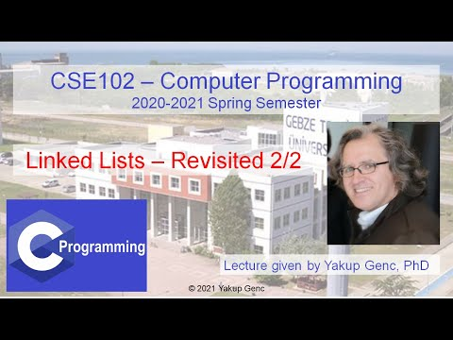

[CSE102 Lecture on 2021-05-25 Part 1 of 2](https://youtu.be/Dpsdi8jym1Y)

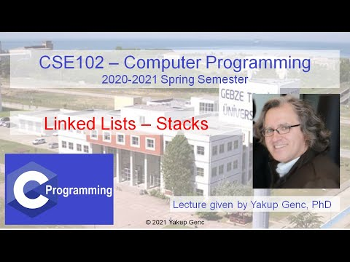

[CSE102 Lecture on 2021-05-25 Part 2 of 2](https://youtu.be/Vv9HFF5Oqsk)

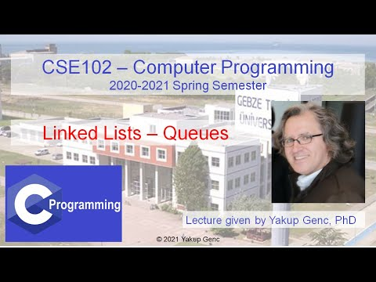

[CSE102 Lecture on 2021-05-26 Part 1 of 2](https://youtu.be/BhrXklsvRHg)

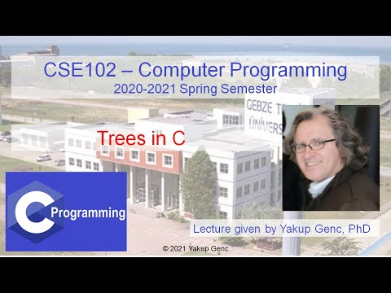

[CSE102 Lecture on 2021-05-26 Part 2 of 2](https://youtu.be/cAXsjJyNS2k)



[CSE102 Lecture on 2021-05-31 Part 1 of 2](https://youtu.be/TEJB3o8I-H4)

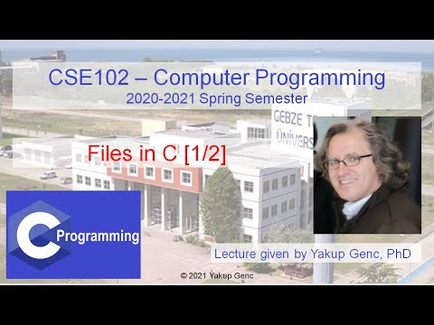

[CSE102 Lecture on 2021-05-31 Part 2 of 2.](https://youtu.be/MXZ6yBRP9DU)

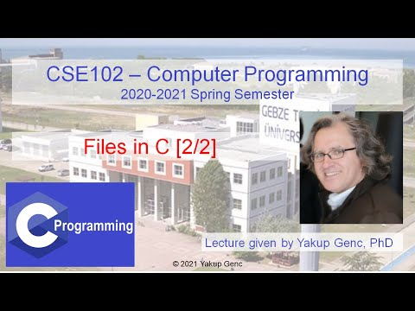

[CSE102 Lecture on 2021-06-01](https://youtu.be/1xABAuH9miQ)

